WEEK 1 PROBLEMS:

1. import java.util.*;

public class p1{

public static void main(String[] args){

Scanner sc=new Scanner(System.in);

long x=sc.nextLong();

if(x>=-128 && x<=127)

{

System.out.println("*byte");

}

if(x>=Short.MIN_VALUE && x<=Short.MAX_VALUE)

{

System.out.println("*short");

}

if(x>=Integer.MIN_VALUE && x<=Integer.MAX_VALUE)

{

System.out.println("*int");

}

if(x>=Long.MIN_VALUE && x<=Long.MAX_VALUE)

{

System.out.println("*long");

}

}

}

OUTPUT: 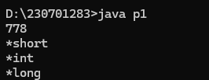

2. import java.util.*;

public class p2{

public static void main(String [] args){

Scanner sc=new Scanner(System.in);

int n;

n=sc.nextInt();

double c;

c=n/100.0;

System.out.printf("%.2f\n",c);

}

}

OUTPUT: 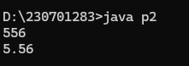

3.import java.io.*;

import java.util.*;

public class p3{

public static void main(String [] args){

Scanner sc=new Scanner(System.in);

int s=sc.nextInt();

double p=sc.nextDouble();

double k=s*(p/100);

double total=s+k;

System.out.println("New Salary:"+total);

}

}

OUTPUT:

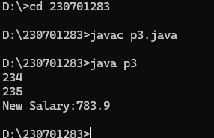

4. import java.util.*;

public class p4{

public static void main(String [] args){

Scanner sc=new Scanner(System.in);

int s=sc.nextInt();

double p=sc.nextDouble();

double k=s*(p/100);

double total=s+k;

System.out.println("New Salary:"+total);

}

}

OUTPUT:

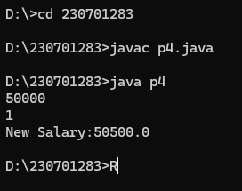

5. import java.util.*;

PUblic class app1{

public static void main(String s[]){

Scanner sc=new Scanner(System.in);

int a=sc.nextInt();

int ori = a;

int rev=0;

int rem,q;

while(a!=0){

rem=a%10;

rev=rev*10+rem;

a=a/10;

}

if(rev==ori){

System.out.print("The reversed number is"+rev+".It is the same as original number.");

}

else{

System.out.print("The reversed number is"+rev+".It is not same as original number.");

}

}

}

OUTPUT: 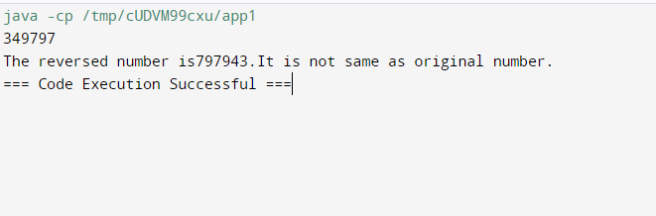

7:

import java.util.*;

public class p7{

public static void main(String[] args) {

Scanner scanner = new Scanner(System.in);

System.out.print("Enter the value of n: ");

int n = scanner.nextInt();

for (int i = 0; i < n; i++) {

for (int j = 0; j < n - i - 1; j++) {

System.out.print(" ");

}

int val = 1;

for (int j = 0; j <= i; j++) {

System.out.print(val + " ");

val = val * (i - j) / (j + 1);

}

System.out.println();

}

for (int i = n - 2; i >= 0; i--) {

for (int j = 0; j < n - i - 1; j++) {

System.out.print(" ");

}

int val = 1;

for (int j = 0; j <= i; j++) {

System.out.print(val + " ");

val = val * (i - j) / (j + 1);

}

System.out.println();

}

}

}

Output:

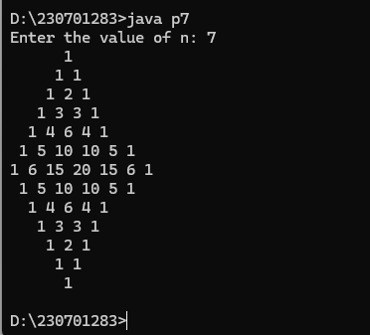

8.

import java.util.*;

class p8 {

public static void main(String[] args) {

Scanner sc = new Scanner(System.in);

int q = sc.nextInt();

for (int i = 0; i < q; i++) {

int a = sc.nextInt();

int b = sc.nextInt();

int n = sc.nextInt();

int sum = a;

for (int j = 0; j < n; j++){

sum += (int)(Math.pow(2, j) * b);

System.out.print(sum + " ");

}

}

}

}

Output:

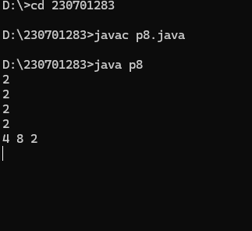

6.

import java.util.*;

class p6{

public static void main(String args[]){

Scanner sc=new Scanner(System.in);

int n=sc.nextInt();

int i;

int j;

for(i=1;i<=n;i++){

for(j=n;j>i;j--){

System.out.print(" ");

}

for(j=i;j>=1;j--){

System.out.print("*");

}

for(j=2;j<=i;j++){

System.out.print("*");

}

System.out.println();

}

for(i=n-1;i>=1;i--){

for(j=n;j>i;j--){

System.out.print(" ");

}

for(j=i;j>=1;j--){

System.out.print("*");

}

for(j=2;j<=i;j++){

System.out.print("*");

}

System.out.println();

}

}

}

Output:

